



Odd Sock Pie

This is a great recipe for using up all those odd socks which are at the back of your draws. Collect up all the odd socks in the house. It doesn’t matter if they are clean or sweaty. In fact, the sweaty ones will add extra flavour. Then see if you also have any old PE shoes or football boots which are too small. It helps if they are covered in mud.

Ingredients:
- 11 old socks (preferably sweaty)
- 3 old PE or football boots (they must be muddy)

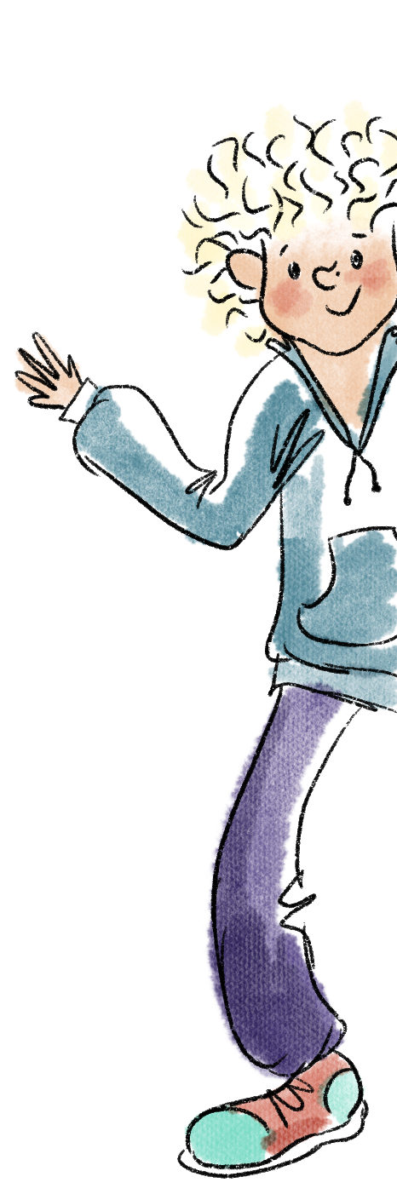
- 5 duck feathers
- 2 handfuls of weeds from the garden
- Half an egg custard
- 2 carrots
- 9 small green grapes
- 18 cloves of garlic
- 500grams of chilli powder
- Sea salt and fresh pepper
- 2 large sheets of pastry to make the lid of the pie.

Put all the ingredients in the washing machine for 1 week,
Mix well
Grease a large pie dish
Put all the ingredients from the washing machine in the pie dish
Dance on it for 4.25 minutes
Then cover with pastry lid and leave on windowsill for 6 days.

Serve when there is nothing else left in the house with fresh bread rolls and butter.

