



.
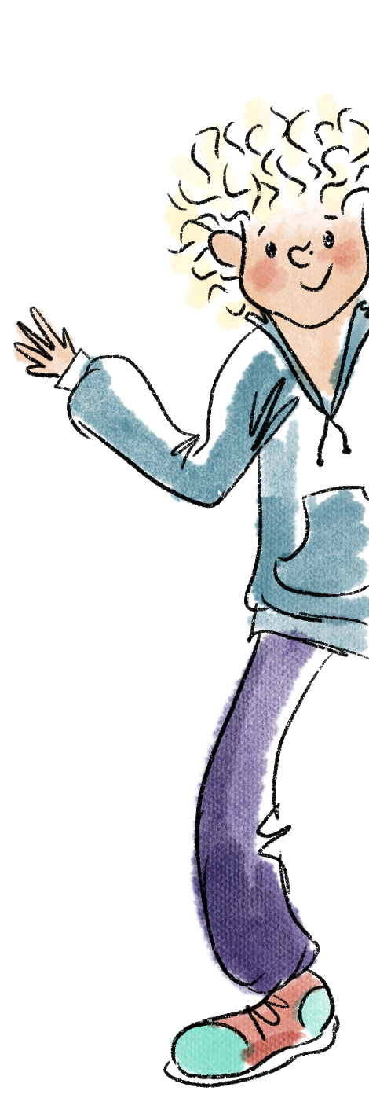
Very Nearly Vegan Curry
- 2 sausages
- 3 chicken fillets
- 1 sirloin steak
- 2 tins of tuna in oil

- 19 slices of ham
- 7 pigs trotters
- 1 jar of ready-made curry
- A whole cauliflower

Mix well in a blender for 3 hours

Tip in a big pan

Leave on the side till a parent comes into the kitchen and ask them to simmer for 10 mins

Serve with salt and vinegar crisps.

