

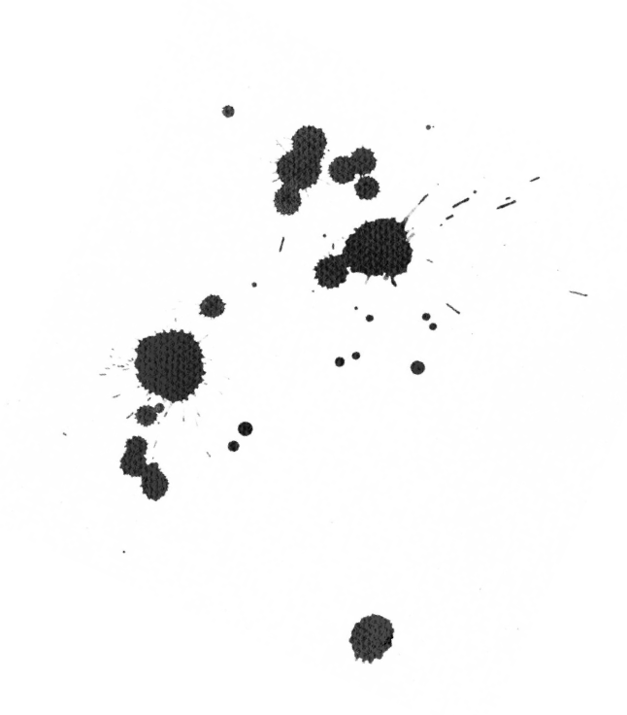

.
Now this Puts Hair on Your Chest Casserole.

Ingredients:

- 8 ounces of pineapple chunks
- 2 large handfuls of flowers
- A spare tyre
- 2 sultanas
- 1 slightly red slightly green grape
- 22 white Spanish onions
- 24.5 egg yolks

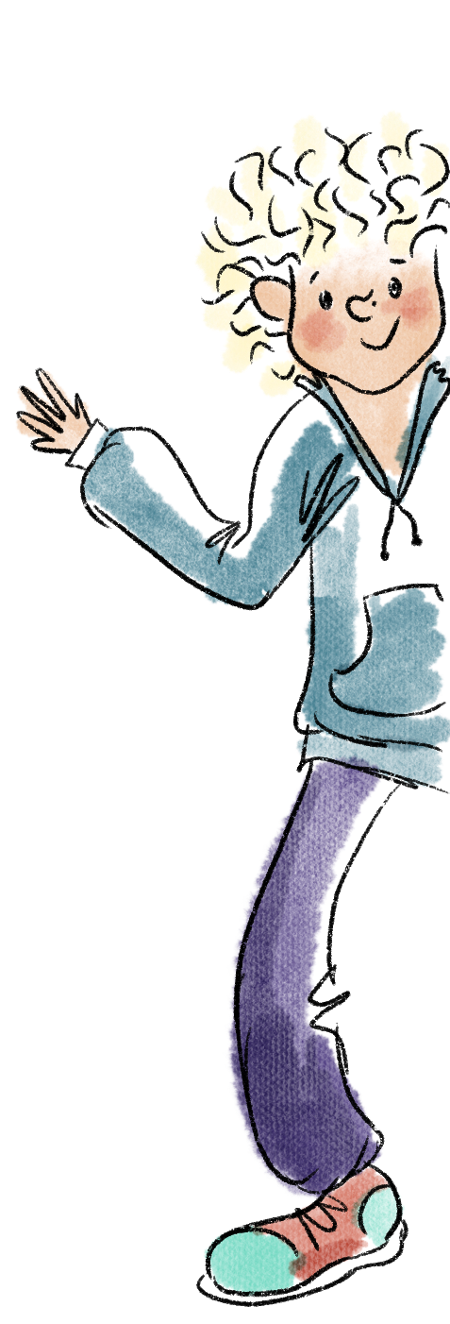
Place all ingredients in a bin bag, rest at the end of the garden for 12 years, 7 months, 4 days, 2 hours and 16 minutes 99 seconds at room temperature. Then cook slowly for 33 minutes and serve with fresh garlic bread.

